Heuristic Evaluations Ariana Daly

**Barun Kwak**

<https://invis.io/QAFSJ1CEJWZ#/278646581_home_Screen>

1. H2-1 Visibility of System Status:

Added to Cart Pop-up Page

* 1. Page complies, shows that the system added an item to the cart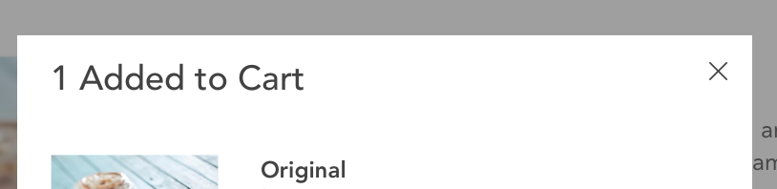

Cart Checkout Page

* 1. Page complies, as it clearly shows the number of items in the cart with (1)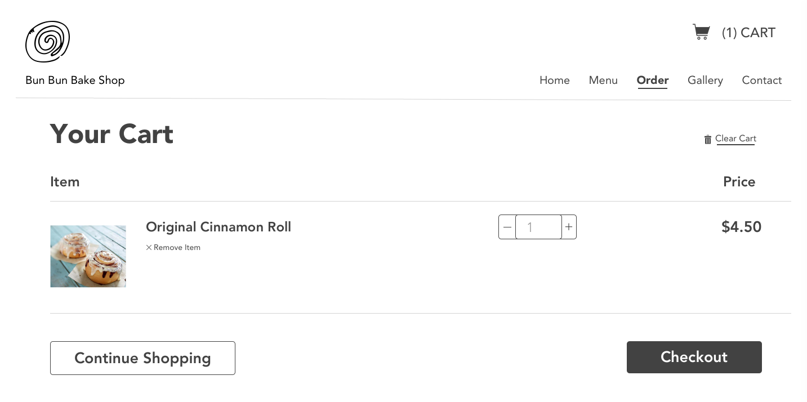

1. H2-2 Match Between System and Real World:

Cart Checkout Page

* 1. Page complies, cart icon for viewing items that will be purchased on checkout and garbage can icon to indicate removing items from cart 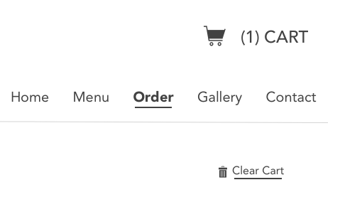

1. H2-3: User Control and Freedom:

Original Roll Detail Page-

* 1. Does not comply, after click on the quantity or glaze drop down menu, you cannot close that menu by clicking on other parts of the page- instead you need to click 1 or the glazee again to maintain your selection. Typically you can click outside the menu to close it.

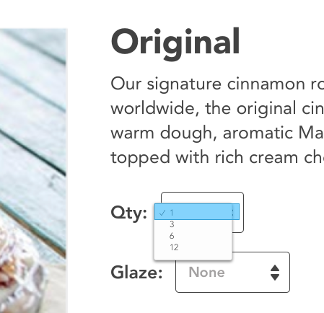

Add to Cart Pop Up-

* 1. Complies, there’s several ways to exit the page. You can click outside the popup or click the x to close it. It’s clear that you can click Continue Shopping or View Cart & Checkout to proceed.

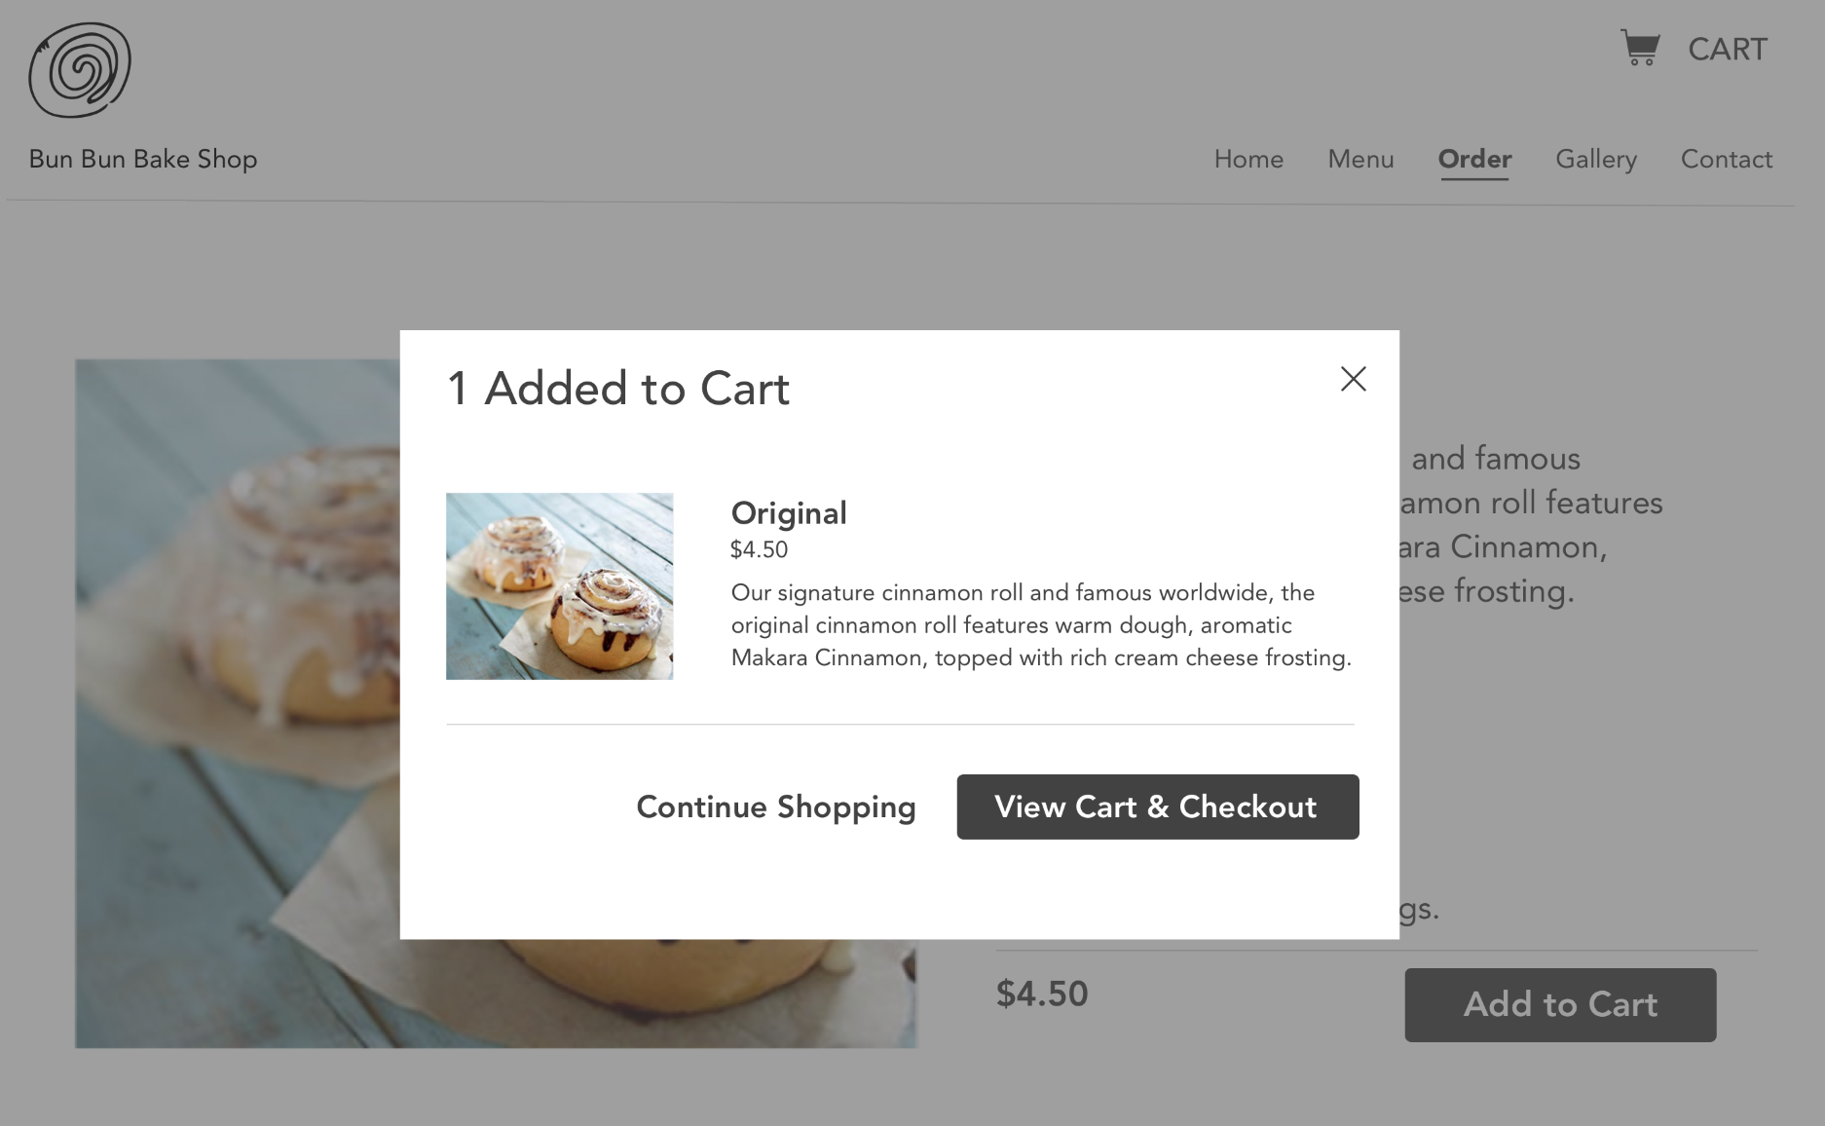

1. H2-4 Consistency and Standards:

Original Roll Detail Page

* 1. Does not comply, when you click on “Glaze”, the Allergies text changes to Allergens.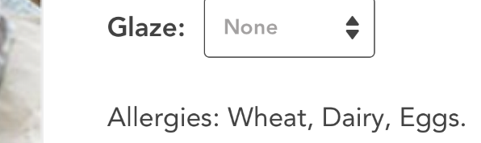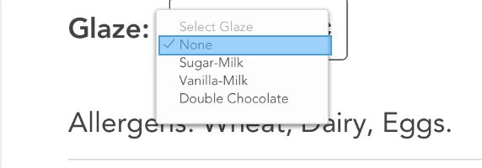

1. H2-8 Aesthetic and Minimalist Design:

Contact Page

* 1. Complies, succinctly and clearly shows the relevant contact information

**Rich Zhu**

<https://invis.io/FUFUWPOAQ6H#/279383296_Homepage>

1. H2-1 Visibility of System Status:

Product Page 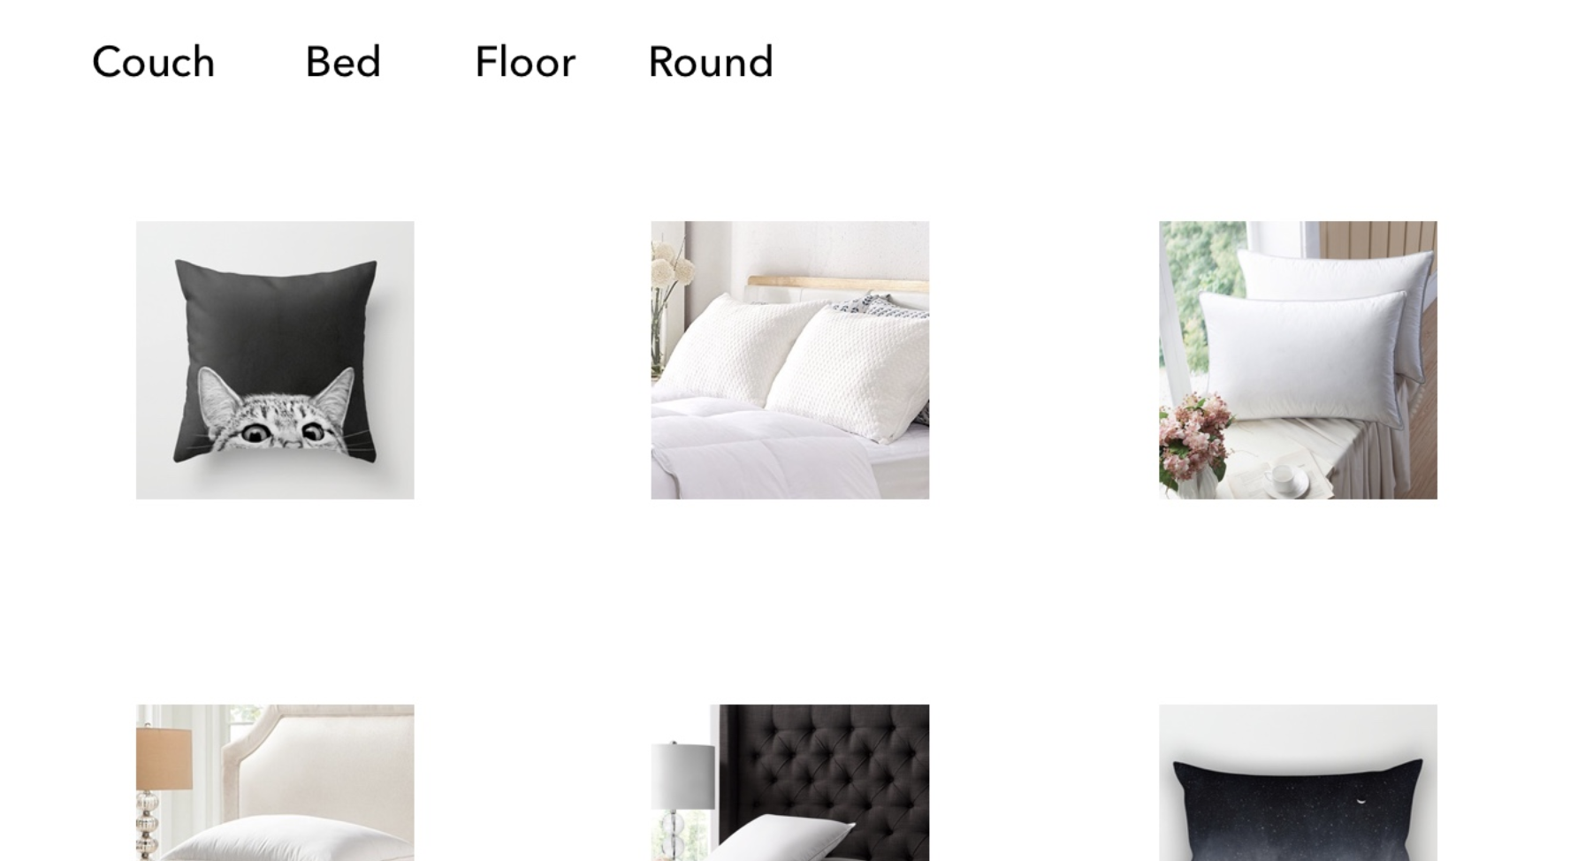

* 1. Does not comply, there’s no clear indication that the titles above are filters vs links to a different page. If they are filters, having some indication that the page is currently not filtering/showing all pillows can be helpful

1. H2-2 Match Between System and Real World:

View Cart Page

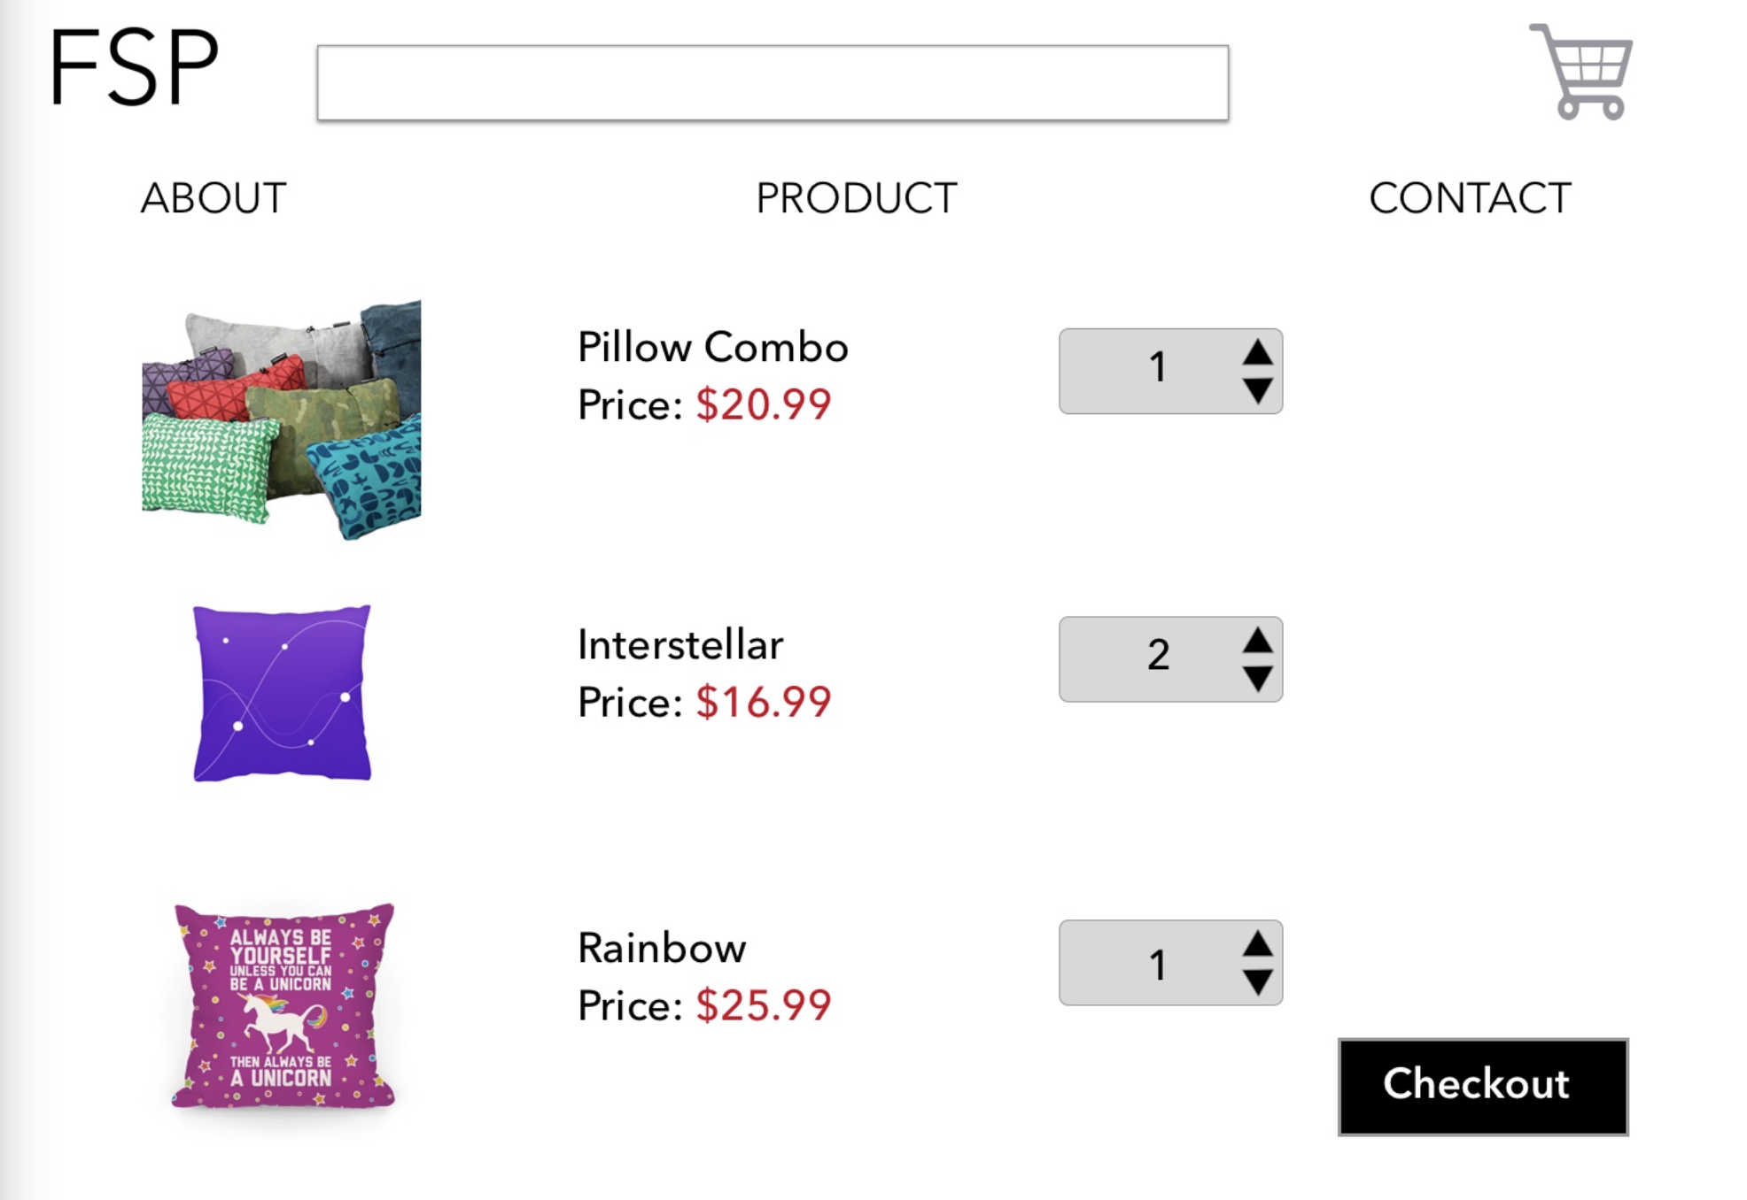

* 1. Does not comply, typically when checking out in the real world, you would get a total price before paying. This page shows the individual prices, but doesn’t show a total price for all of the products

1. H2-3: User Control and Freedom:

Buy now/Checkout Pages

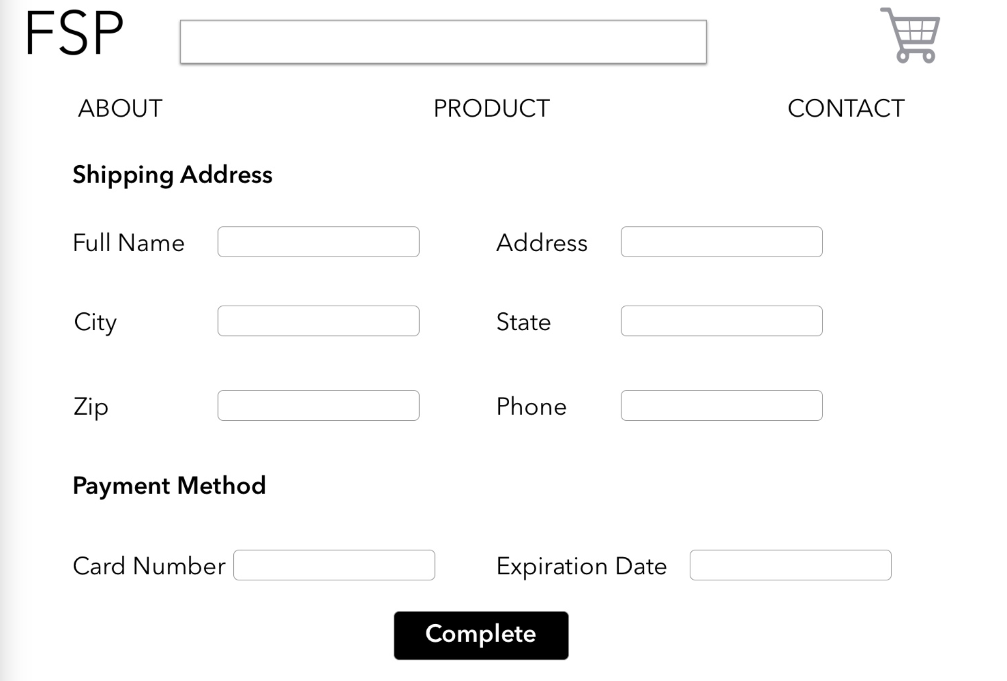

* 1. Does not comply, there’s no way to directly go back to the product detail page if you change your mind about checking out

1. H2-4 Consistency and Standards:

Home Page

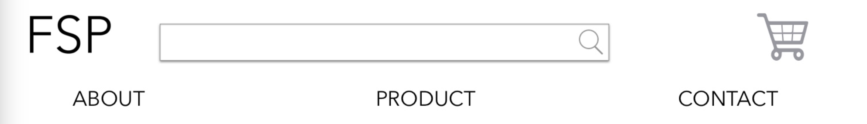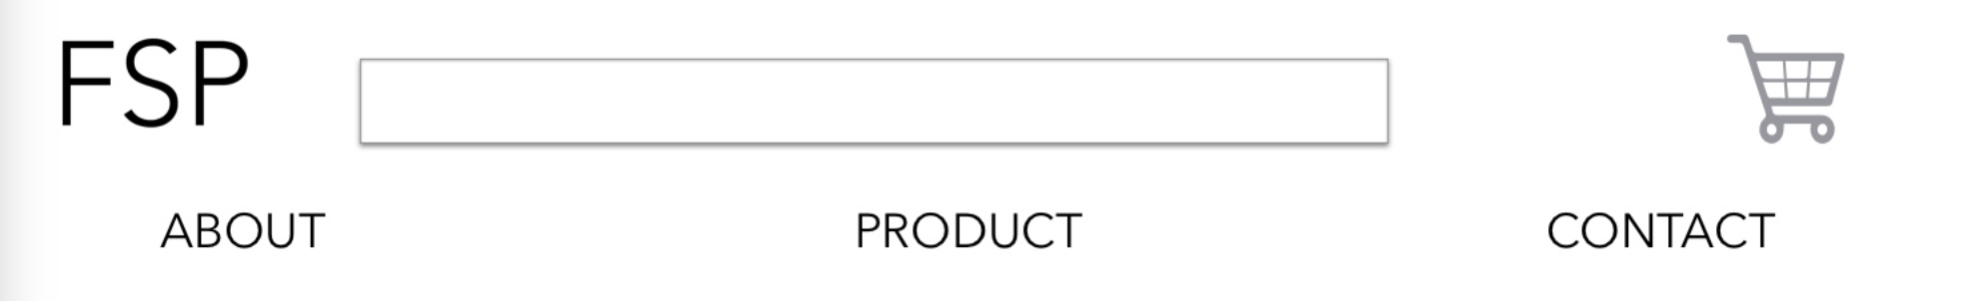

* 1. Does not comply, the magnifying glass on the search bar is on the home screen, but disappears on other pages

Home Page + Product Page

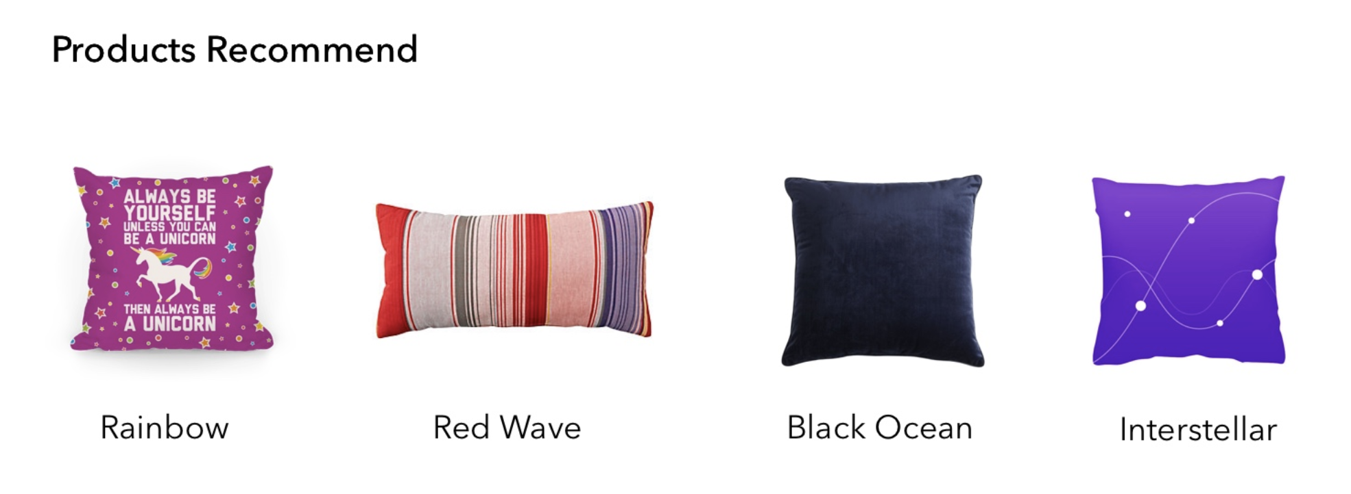

* 1. Does not comply, the home page lists the name of the product below it, but the product page doesn’t list a name. Typically products will have a name and price below it, so the lack of a price is unusual.

1. H2-8 Aesthetic and Minimalist Design:

Contact Page

* 1. Complies, overall I don’t see any unnecessary information, and the design is minimalist